Name of the Department  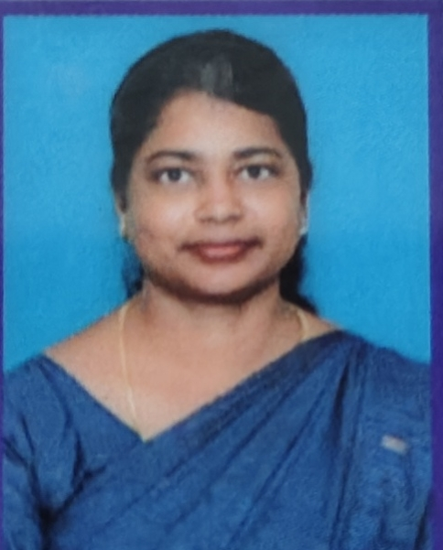 |  |  | : | Nutrition and Dietetics
Name of the faculty member |  |  | : | J.V.Nisha
Present Designation |  |  | : | Assistant Professor
Residential Address |  |  | : | Amsikkakuzhi ,  Methukumal (P.O),  Kanyakumari District- 629172
Contact Nos. |  |  | : | Landline: Mobile 7825034652  Email : jvnisha08@gmail.com
Gender |  |  | : | FEMALE
Community |  |  | : | BC
PAN Number :
Date of Birth and Age |  |  | : | 28/05/1991 / 34
Date of Joining the present post |  |  | : | 03/07/2025
Date of Retirement  Scale of pay |  |  | :  : | 03/07/2051
Present basic pay |  |  | :
Total salary |  |  | : | 12000
- Particulars of Educational Qualifications: (Awarded only) Ref.No./Date/Copy to be enclosed

Category | Name of the Degree | Specialization | Year of Passing | Name of the College | Name of the University | % of Marks / Grades secured | Class obtained
UG | B.Sc | Nutrition and Dietetics | 2003 | Muslim Arts college,  Thiruvithancode | Manonmaniam Sundaranar University, | 70 | I
PG | M.Sc | Nutrition and Dietetics with Hospitality management | 2012 | Muslim Arts college,  Thiruvithancode | Manonmaniam Sundaranar University, Tirunelveli | 71 | I
M.Phil | M.Phil | Food and Nutrition | 2015 | Gandhigram RuralUnivrsity  Dindigul. | Gandhigram RuralUnivrsity  Dindigul. | 72 | I
Ph.D | - | - | - | - | - | - | -

1. Additional Qualification :

NET / SLET : Nil

- II. a. Title of Ph.D. Thesis :
DISTRICT
b. Faculty/Discipline/Subject in which Ph.D.
was awarded :

III.a. Number of Ph.D scholars completed:

S.No | Name of the Scholar | Register Number | Year of completion | Name of the University

b. Ph. D scholars under Guidance (University wise):

S.No | Name of the Scholar | Register Number | Date of Registration | Name of the University

c. Research projects received from various funding agency:

S.No. | Title of the Project | Funding Agency | Period | Plan/Scheme | Amount |  | Completed | Ongoing
 |  |  |  |  | Sanctioned | Received | Completed | Ongoing

IV. Academic Experience:

Name of the College | Govt/Aided/S.F. | Designation | Joining Date | Relieving Date | Experience
 |  |  |  |  | Years | Months | Days
Muslim Arts College, Thiruvithancode | Self Finance | Assistant Professor | 28.01.2015 | 11.04.2017 | 2 | 3
Infant Jesus College of Arts and Science for Women, Mulagumoodu | Self Finance | Assistant Professor | 03.07.2025 | Till Date
TOTAL |  |  |  |  | 02 | 3

V. Administrative/other Experience:

Name of the Organisation | Designation | Nature of Work | Joining Date | Relieving Date | Experience
 |  |  |  |  | Years | Months | Days
Total

VI. Other Relevant Information : ---
It is certified that all the information provided are true to the best of my knowledge.

Signature of the Faculty
(Endorsement by the Principal)

